44.29: a) The antiparticle must consist of the antiquarks so:
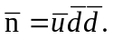
b) So 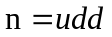is not its own antiparticle
c) 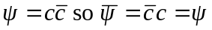so the is its own antiparticle.

